Managing a Successful Computing Project

GCD0821

Dương Quang Sang

GDC17274

# ASSIGNMENT 2 FRONT SHEET

|  |  |  |  |
| --- | --- | --- | --- |
| **Qualification** | **BTEC Level 5 HND Diploma in Computing** | | |
| **Unit number and title** | Unit 06: Managing a Successful Computing Project | | |
| **Submission date** |  | **Date Received 1st submission** |  |
| **Re-submission Date** |  | **Date Received 2nd submission** |  |
| **Student Name** | Duong Quang Sang | **Student ID** | GCD17274 |
| **Class** | GCD0821 | **Assessor name** | Ngo Ngoc Tri |
| **Student declaration**  I certify that the assignment submission is entirely my own work and I fully understand the consequences of plagiarism. I understand that making a false declaration is a form of malpractice. | | | |
|  | | **Student’s signature** |  |

**Grading grid**

|  |  |  |  |  |  |
| --- | --- | --- | --- | --- | --- |
| P5 | P6 | P7 | M3 | M4 | D2 |
|  |  |  |  |  |  |

|  |  |  |
| --- | --- | --- |
| * **Summative Feedback:**  **Resubmission Feedback:** | | |
|  |  |  |
| **Internal Verifier’s Comments:** | | |
| **IV Signature:** | | |

Contents

LO3 Present the project and communicate appropriate recommendations based on meaningful conclusions drawn from the evidence findings and/or analysis 5

P5 Analyse research and data using appropriate tools and techniques 5

P6 Communicate appropriate recommendations as a result of research and data analysis to draw valid and meaningful conclusions. 11

M3 Evaluate the selection of appropriate tools and techniques for accuracy and authenticity to support and justify recommendations. 13

LO4 Reflect on the value gained from conducting the project and its usefulness to support sustainable organisational performance 14

P7 Reflect on the value of undertaking the research to meet stated objectives and own learning and performance 14

M4 Evaluate the value of the project management process and use of quality research to meet stated objectives and support own learning and performance 15

References 17

# LO3 Present the project and communicate appropriate recommendations based on meaningful conclusions drawn from the evidence findings and/or analysis

# P5 Analyse research and data using appropriate tools and techniques.

-Based on quantitative research have analysed , project based on appropriate tool in the following the result of the research has been given by surveying with 300 customer

**Survey form**

|  |  |  |  |  |
| --- | --- | --- | --- | --- |
| **Survey Question** | **Strongly**  **agree** | **Agree** | **Disagree** | **Strongly**  **disagree** |
| This project will help users save a lot of  time | 70% | 15% | 10% | 5% |
| The project is really easy to use and  friendly to customers | 72% | 13% | 10% | 5% |
| The project ensures confidentiality of  customer information | 50% | 20% | 10% | 10% |
| This project will motivate the company to  grow | 43% | 27% | 18% | 12% |
| Payment is possible in any form | 50% | 30% | 15% | 5% |
| Express delivery | 70% | 20% | 6% | 4% |
| This project gives customers a new  experience | 40% | 30% | 20% | 10% |



**This project will help users save a lot of time2**

**10% 0%**

**15%**

**5%**

**70%**

Strongly agree Strongly Disagree Agree

Disagree

**Looking at this chart**, we can see through interview of the 300 customer, we find Strongly agree occupies the highest percentage (70%).In addition, Agree and Disagree are equally chosen with (15% & 10%). However, strong disagree only holds very low use with 5%.

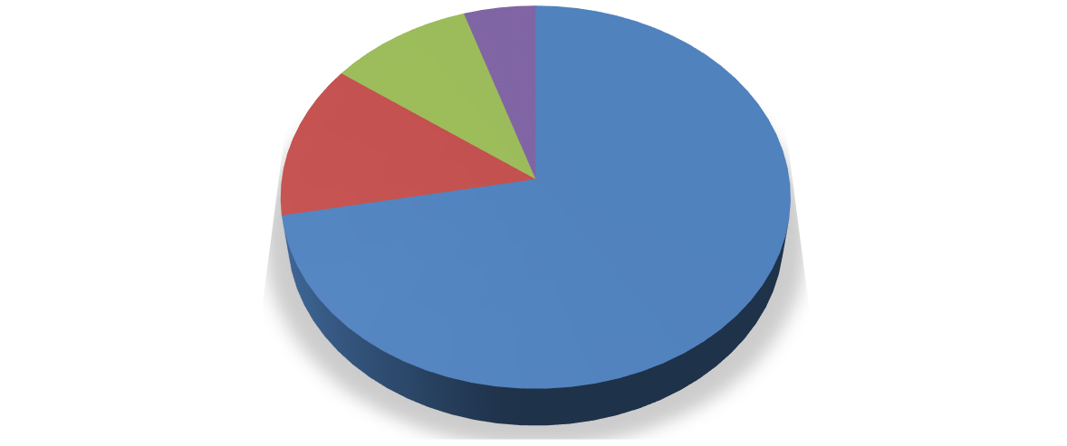

**The project is really easy to use and friendly to customers**

**Strongly disagree**

**Disagree 5%**

**10%**

**Agree**

**13%**

**Strongly agree 72%**

Strongly agree Agree Disagree

Strongly disagree

More than 72% of respondents using products in Da Nang showed that this product is very friendly and easy to use. There are some people who first experience the product they feel like it (13%). In addition, some people do not know how to use the product very difficult to use (10%). Finally, there are some customers who feel they are not adapted to our product and think it is difficult. instead of traditional methods (5%)





**THE PROJECT ENSURES CONFIDENTIALITY OF CUSTOMER INFORMATION**

Stronly agree Agree Disagree Strong disagree

**11%**

**11%**

**56%**

**22%**

**From the chart**, we can see that the most important security requirement the company needs to fulfill in their requirements, according to customers, is strongly agree (56%). Next is agree (22%)and finally, disagree and strongly disagree (11%)

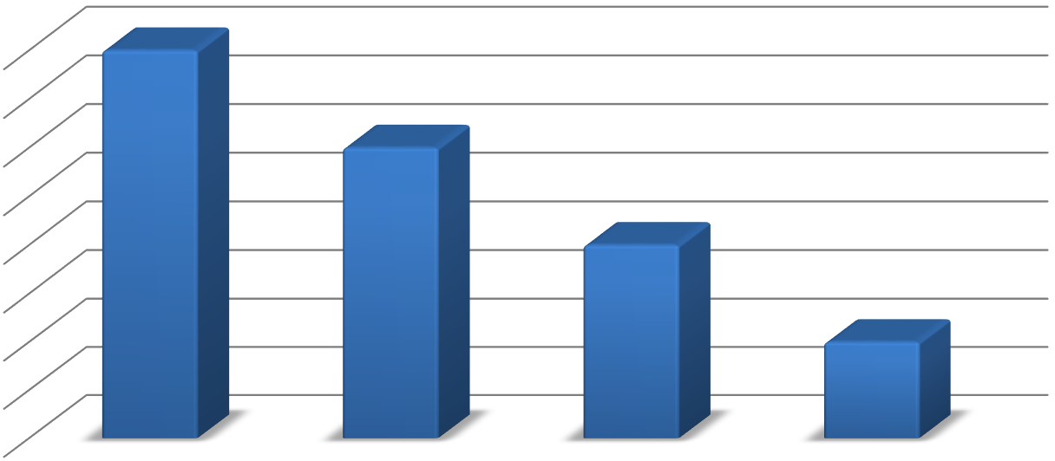

**This project gives customers a new experience**

40

35

30

25

20

15

10

5

0

Strongly Agree

Agree

Disagree

Strongly Disagree

This project gives customers a new experience

Look at the chart we can see:

The answer “strongly agree” chosen the most with 40 % ; Agree was ranked second with 30%

; Both Disagree and Strongly disagree were chosen equally with 20% ; B was chosen at least 10%

.

**THIS PROJECT WILL MOTIVATE THE COMPANY TO GROW**

This project will motivate the company to grow

S T R O N G L Y D I S A G R E E

D I S A G R E E

A G R E E

S T R O N G L Y A G R E E

43

27

18

12

Looking at the chart, we can see the answer Strongly agree was choice most with 43%, Agree was the second most popular with 27%, the remaining Disagree y and Strongly Disagree with 18% and 12%.

**PAYMENT IS POSSIBLE IN ANY FORM**

**Strongly disagree 5%**

**Disagree 15%**

**Strongly agree**

**50%**

**Agree**

**30%**

Look at the chart we can see the answer strongly agree was choice most with 50%, Agree was the second most popular with 30% and the remaining Disagree and Strongly Disagree 15% and

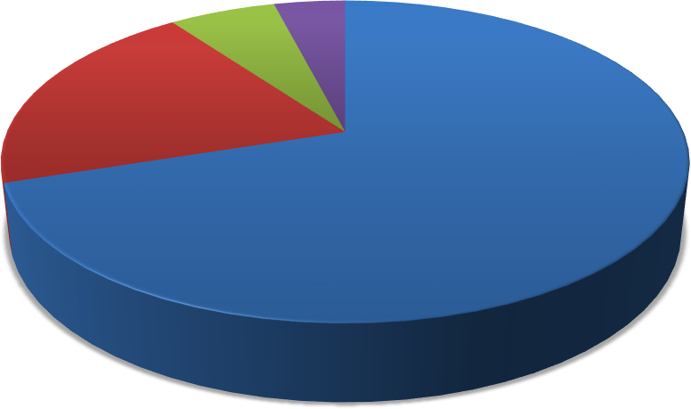

**Express delivery**

DisSatgrorenegly disagree

6%

4%

Agree

20%

Strongly agree

70%

Strongly agree Agree Disagree Strongly disagree

5%.

Looking at this chart, we can see through interview. We find Strongly Agree occupies the highest percentage 70%. In addition, Agree and Disagree are equally chosen with 20% and 6% .However, Strongly disagree only holds very low use with 4%.

# P6 Communicate appropriate recommendations as a result of research and data analysis to draw valid and meaningful conclusions.

From the analysis of the research data using appropriate tools and techniques, the recommendation are given in the following:

The following are tried-and-true methods of connecting external stakeholders to the materials that communicate the evaluation results.

**Enhance your web presence**. Snapshots, case studies, stories, visual aids, and even your final report should be made available on your program’s website, Facebook page, or any other online communities you are part of, including a non-profit management association or any associations of management-support organizations.

**Develop press releases.** Draft a press release highlighting the strongest results you have discovered and distribute to local newspapers, columnists, bloggers, community email lists, and neighbourhood organizations.

**Issue a formal report**. At the conclusion of the project, complete a full report of your evaluation efforts. Describe your desired outcomes and your logic model, the data collection plan, your results, and any recommendations or actions you have taken or plan to take as a result.

**Sponsor, potential and present**. This is most likely the first object that capacity builders will think to target, and rightly so; Effective communication of your services is the key to sustainability. Your product creates to meet the needs of stakeholders such as customers and investors that will help succeed.

**Human resources:** To get the advantage of human resources, the project needs to use human resources as unemployed, as students do. Because this is not an extremely difficult job for them and has a light income for them.

**Organize your customers**. Throughout the process, we have encouraged capacity builders to work closely with organizations that are part of capacity building participation. This should not stop when delivering results. In addition to any results for that specific organization, provide the overall results of the program to give the organization an idea of how they compare to others in their cohort. This builds the goodwill that organizations have for your organization and builds your reputation across the nonprofit region. This can help create opportunities that will inevitably return to sponsors and also create more needs for your services.

**Completion of legal procedures:** It is necessary to have the consent of the facilities as well as the stakeholders (government, ..) in order to be able to operate the project, there must be an operation certificate.

**Managers and employees in your organization**. This stage is very important, to complete a project, there must be an experienced staff in project management and an experienced project manager.

**Complete the budget**: In order to complete a project, it is necessary to manage the existing human resources in order to be able to provide it when implementing the program and have enough money to run the project.

**Product:** With a project to order food online, the product focuses primarily on food and drinks, in addition to the thoughtful service of staff because the time customers stay at home waiting for staff shipping in a short time. And can add missing products through customer requirements.

# M3 Evaluate the selection of appropriate tools and techniques for accuracy and authenticity to support and justify recommendations.

Using some tools such as **Excel** and **project management software** from data analyzed and surveyed from **300 customers** of the online food reservation project, recorded specific data through each chart and opinion. Of customers about the project. Ensure the accuracy of each information for the project and can be done accurately to meet the needs of customers.

**Respondent 1**: Through the above survey with each customer and staff at the facility, there are some unsatisfactory comments and some very consensus ideas about opening a website Serving the Recipe Eat and drink water. With the first customer asked, he completely agreed with 70% of the project . They often use our website and they think it helps them save a lot of time and not moving to the street to buy food. They agree to recommend this software for many another object.

**Respondent 2:** With a second customer who seems to disagree with this idea, he thinks that with a very convenient purchase today, there are many reputable websites like "Grab" or "Now delivery" Just place an order through reputable companies that they can accept. Therefore, there is no need to open more food ordering sites that will cut traffic when there are many deliveries. This person that they don't like things too convenient. It makes people lazy more cowards and depends too much on technology. Affect the ability of people's daily activities. Make them increasingly lazy

**Respondent 3:** When asked about a third customer about the project about projects, he found this project very attractive and most of his friends liked this type because it could be picked up immediately. With just click mouse he can have his favorite food and save his time. Use and transport items very close. This item will be available in a single note instead of waiting for remote transfer or can go down and choose what you need at your convenience.

# LO4 Reflect on the value gained from conducting the project and its usefulness to support sustainable organisational performance

# P7 Reflect on the value of undertaking the research to meet stated objectives and own learning and performance.

Both **qualitative** and **quantitative researc**h methods are effectively implemented to meet the objectives of the project.

**Quantitative research** has revealed that most customers want quality, affordable products. Besides **quantitative** research also shows that the project can find the right place to perform.

The work breakdown will help the project manager to set specific task. describe activities to be carried out in a clear and complete manner. According to the structure, the manager will be able to complete the project tasks within the time limit. In addition, Gantt's chart the project has specified the time required for each task. The Gantt chart has also specified the duration of mission, so that the manager will be able to complete the task in the limited time project space. **Through the survey questionnaire, there are still many issues that need to be fixed:**

* Negotiation skills
* Communication skills
* Understand about content

# Project management Learning and performing separately:

**Risk management:** All projects carry risk and being able to identify and manage risk is definitely something that new project managers should work on, even if you don’t have formal risk management processes set up in your organization. Through the project, we learned some lessons about project risk control and quality helps to implement the project smoothly and achieve higher efficiency.

**Planning:** Through the project, I realized that I needed a specific plan for the project such as a specific plan in the future. It helped me to control and implement it.

**Negotiation skills:** When working on a project, you will learn many skills, including interactive communication skills to help you achieve the project. Get an idea of how to manage stakeholders and deal well with customers.

**Budget Management:** Control is the most important reality of a project and I have great ideas and techniques on a project's cost control process. It helps you track your budget and save costs.

**Communication skills:** Communication helps the project progress rapidly according to its wishes. When communicating you can learn a lot of information from customers to be able to change in time provide standards and enough for the project.

**Writing skill:** Through this project I learned and practice more writing skills for project report and research report with the with full content.

**Research skills:** Through the project, I had had more knowledge about the quantitative research and qualitative research. Then I have opportunity to apply them in the same time to collect the base data for my project.

# M4 Evaluate the value of the project management process and use of quality research to meet stated objectives and support own learning and performance.

**Performance review**

-To create the project, the main goal and point of the online food ordering and management system is to provide the needs for customers and employees at the facility. With the support of this project from the owner and the government department, the canteen project has been licensed to operate at this facility.

-Recognize and understand the business environment and its cultural impact on the project at hand from both external and internal sources. Keep up with technology change and find the easiest ways to develop ants. New knowledge and skills needed to implement new projects. Create a team that uses the right set of skills, trains project members, assigns responsibility to representatives and promotes support and similarity work.

-In order to evaluate the completion of the project, it will be through what is considered to be completed and in the process of working, sometimes losing the will to continue to implement but because the project is completed.

-It is planned to follow the method over time according to the first stage and try to clash to convince government agencies and owners. Learn many lessons from the bosses and the main factor to complete the project is investors. Solving the above issues helps the project be more successful and through creating trust for the next project.

# Template for Project Logbook

|  |  |
| --- | --- |
| **Project name: Order food online & Management System** | **Name: Dương Quang Sang** |

|  |  |
| --- | --- |
| **Date:8/6/219** |  |
| **Descriptions** | **Comments** |
| **Update on weekly research/tasks achieved**   1. What have you completed? 2. Are you on track and within deadlines set? 3. Did you need to make any changes to your project management plan? 4. Did you complete all solicitations from the undertaking? 5. Did you have to roll out any improvements   to your task the board plan? | 1.Project 2.Yes 3.Yes |
| 4.Yes |
| 5.Yes |
| **Any risks and/or issues identified?** |  |
| 1. Did you identify risks/issues with a lack of skills | 1.Yes |
| required for undertaking research/tasks? |  |
| 2.Did you identify any additional risks/issues that | 2.Yes |
| have an impact on the project management plan? |  |
| 3. Have you distinguished the dangers / problems | 3. No, I absolutely have the important ability to |
| from not having the aptitude expected to consider | explore an answer. |
| errands? |  |
| 4.Do you distinguish any danger /problem affecting the operating plan task?? | 4.Actually, I have some problems with some  customers that make me change |
| **Problems encountered**  Points to consider:  What barriers did you face? How did you overcome them? | 1. I have problems such as technical barriers, limited resources and communication barriers 2. Negotiate with them about the criteria   that the project has and can meet what they understand |

|  |  |
| --- | --- |
| **New Ideas and change of project direction**   1. What Have I found out about myself this week? 2. How can I feel when I need to manage chores / problems? 3. How well have I performed? What did I contribute? 4. What can I improve on next week? | 1. I have found a bitter way to communicate, organize and control danger 2. I have learnt cost control, communication, negotiation in a better way, as well as research methods.   3.I solved a big joint venture and did very well to perform effective tasks  4.I can save more cost in the next project |
| **Tasks planned for next week**  Points to consider:   1. Which tasks are priority? 2. Have you set aside sufficient time for completion? | 1. The most important task is to have a good plan 2. Yes |
| **Project plan status to date : (on, ahead,**  **behind)** |  |
| **Comments and signature of the Tutor** |  |

# References:

[https://vi.scribd.com/document/339959807/Assignment-brief-for-HND-in-Business-Unit-6-Managing-a-](https://vi.scribd.com/document/339959807/Assignment-brief-for-HND-in-Business-Unit-6-Managing-a-Successful-Business-Project) [Successful-Business-Project](https://vi.scribd.com/document/339959807/Assignment-brief-for-HND-in-Business-Unit-6-Managing-a-Successful-Business-Project)